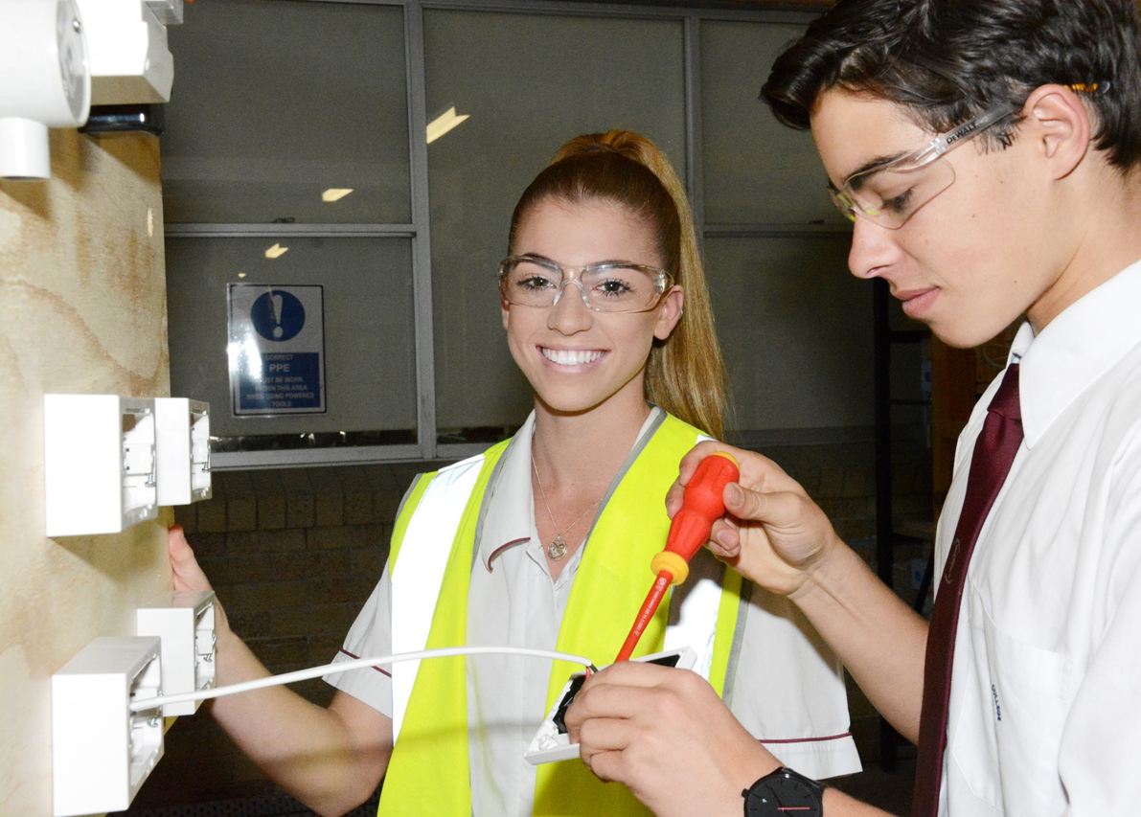

Workplace Learning

Guide for Students

June 2024



## Table of Contents

What is Workplace Learning 3

Guidelines for Workplace Learning programs 4

Steps for finding a great placement opportunity 5

Am I ready to start? 9

What is Workplace Learning?

Workplace Learning (WPL) is all about great learning but in a workplace instead of a classroom. You learn about work and also through work, have access to opportunities that you and your teacher can plan together. Your involvement with planning will help customise these opportunities just for you!

Workplace learning includes work experience, work placement for Higher School Certificate (HSC) Vocational Education and Training (VET) courses, community learning, volunteering, and student mentoring.

What is the difference between work experience and work placement?

### Work Experience

* Gives you a ‘taste’ of the world of work, usually in a workplace or career of your choice.
* Is usually undertaken in Years 9 and 10, but may occur in Years 11 and 12.
* Is organised by the school, or by you with the school’s approval.
* Involves observing and carrying out tasks nominated by your supervisor.
* Helps you learn about what employers expect, what responsibilities people have, and what skills and attributes employers are looking for.
* Helps you learn how enterprises work.
* Gives you a chance to experience working life and test your career aspirations.
* Improves your Employability Skills and gets you thinking about your next step in education or training.
* Gives you increased confidence and maturity by working with adults.
* Helps you find out what you like and don’t like.

### Work Placement

* Is a compulsory part of many HSC VET courses in a workplace relevant to your course.
* Is usually undertaken in Years 11 and 12.
* Is organised through the school using Work Placement Service Providers (WPSPs).
* Lets you practice and develop on-the-job industry skills that are learned off the job at school.
* Lets you learn specific skills or competencies on the job.
* Involves your participation in the industry relevant to your VET studies.
* Helps you find out more about employment and training opportunities in the industry.
* Contributes to your HSC and a nationally accredited qualification recognised by industry.
* Builds your capacity to meet industry standards.

Guidelines for Workplace Learning programs

What work can I do?

Talk to your Careers Adviser, VET Trainer or other teachers about work you can do. Any workplace activities involving risks to your health and safety need to be carefully risk assessed by the host employer before approval is considered. Exemptions to work placement can be found by visiting the Catholic Schools NSW (CSNSW) website and particularly the VET Noticeboard [(http://www.csnsw.catholic.edu.au/ programs-vet/)](https://www.csnsw.catholic.edu.au/vet/) or discuss with your VET Coordinator.

Some workplace learning placements also require you to know about specific work health and safety (WHS) before you can work in the workplace. For example, to be on a building site, you and any accompanying support staff must complete the WHS Induction Training for Construction Work. Similarly, to take part in any VET work placements, you must have done the WHS training in the course beforehand. Ask your Careers Adviser about the WHS requirements of your chosen job area. For more information about WHS, see page 8 of this guide.

Can I do work outside of school hours?

Yes, as where possible you should aim to work the normal hours of your chosen industry for a realistic experience. However, as you are a young person, your VET Trainer or Careers Adviser will advise you on what your school expects of you. A few basics:

* you have to be 14 years of age or older to participate in a workplace learning program
* if under 15 years, workplace learning activities before 7am or after 6pm are prohibited
* weekend/holiday work requires specific approval of the principal, if it is deemed essential
* a school contact must be available for you if you are undertaking WPL outside school hours/terms.

Can I do workplace learning with my family or a place where I already work?

It is better to go somewhere different so you can learn new skills and experience being supervised by another host employer. It is often better not to work with your family as you might get treated differently because you are a family member. You can talk over recognition of prior learning (RPL) for WPL with your organising teacher.

How will I get to the workplace?

You will have to plan your own safe way to and from work and meet any travel costs as this is an important aspect of the program to contribute to your learning.

Support on workplace learning programs

If you have a medical condition, allergy, or medication you need to take, you or an advocate should have already raised it in a planning meeting at school. Before you start at the workplace, let your program coordinator/workplace supervisor know. The medical and allergy information also needs to be included on or with your *Student Placement Record*.

If you have other support needs that require adjustments at the workplace, you will also have to discuss these as part of the planning meeting at school before you start at the workplace.

Steps for finding a great placement opportunity

### STEP 1: Do I need to find my own placement?

Ask your Careers Adviser or VET Trainer if you need to organise your own workplace learning opportunity. If you are going on work placement, a *Work Placement Service Provider* (WPSP) will work with you and your VET Trainer/Coordinator to organise your placement. If you are expected to organise your own placement, go to Step 2.

* If your placement is being organised for you, check with your Careers Adviser or VET Trainer/ Coordinator about registering and completing Steps 3 and 4.

### STEP 2: Where do I look?

* Start with brainstorming ideas, beginning locally and if unsuccessful, look further afield.
* Contact workplaces that other students have been to previously, visit local shops or businesses in the job/industry area of interest or search online.
* Network with your peers, family, friends, teachers and neighbours for potential contacts.

### STEP 3: Applying for a Placement

* Discuss your plans with your Careers Adviser or VET Trainer to check you are on the right track.
* Write a resume and a business style cover letter and send it to the employer or make a phone call to the employer and introduce yourself.
* If appropriate, make and attend an interview time with the employer, take your workplace learning documents, including The Workplace Learning Guide for Employers.
* For the interview, ensure that you:
* dress neatly and appropriately, be polite and friendly and arrive on time
* present your skills in a way that is useful for the employer. For example, if you are applying for a placement with a mechanic, you could say ‘I have a passion for cars’
* be clear about what you can offer and give employers some good reasons to offer you workplace learning.
* Follow up with a phone call. If you are knocked back, keep trying with other employers. Remember, a knock back might be more about the business than about you. Respectfully ask for feedback.
* If you are successful, complete the paperwork.

### STEP 4: Completing the paperwork

* Give your parents/carers a copy of the Workplace Learning Guide for Parents and Carers
* Fill out the sections of the Student Placement Record (SPR) under your teacher’s guidance
* Complete a Work Ready program, [myworkexperience](https://myworkexperience.com.au/auth/login) / [go2workplacement](https://go2workplacement.cls.janison.com/auth/login/?returnUrl=%2F) provide the certificate, **BEFORE** final school approval is provided on the form
* You need to have your Student Placement Record completed and signed by:
* you
* the host employer
* your parent/carer
* the school.

What will be expected of me while I am at the workplace?

**I WILL BE EXPECTED TO:**

COOKERY SKILLS



TEAMWORK

* attend a workplace induction
* participate like a new employee
* behave and communicate appropriately, recognising i am in an adult workplace
* fit in with the rules of the workplace
* dress appropriately for the workplace
* carry out directions i am given by my workplace supervisor, especially about safety
* start on time each day
* take only the allocated time for morning and afternoon tea and lunch and return to my work promptly after all breaks
* contact my workplace supervisor and the supervising teacher as soon as possible if i am unable to attend my placement
* account for absences to my workplace supervisor and my supervising teacher. check whether these absences need to be made up at another time
* attend my placement for the normal hours of work for that job, unless negotiated otherwise

### I ALSO NEED TO:

* be at least 14 years of age
* have a positive attitude
* show enthusiasm and initiative
* be pleasant and appreciative
* be willing to learn and take ownership of your learning
* listen to instructors
* accept and complete duties planned by the workplace supervisor
* ask questions if i am not sure what i am supposed to be doing
* ask how to do something if i am finding it difficult
* ask for another task if a task is completed
* be polite, courteous and well-mannered with all staff, clients and customers
* accept and act on advice given by workplace supervisors
* avoid distracting myself by using my mobile phone, checking my messages or using the business computer/internet to check social media websites
* avoid exchanging personal details with other employees at the workplace.
* take ownership of your learning and think about ‘*What I would like to learn during my work learning placement?’*

Do I have to do school work at the workplace?

* You may be asked to keep a journal of your experiences.
* You may also be asked to conduct some research while you are there. For example, find out about WHS, work practices, role of unions, duties of employees, etc. Check with your supervisor before you start your research.
* Work placement students may have some industry-specific work skills (competencies) formally assessed while they are on work placement.

What happens if I don’t like it?

**Give it a real go!** Talk to your supervisor at work. If you have really tried to make it a positive experience and it’s still not working for you, let your school know as soon as possible. Remember that this is a new experience and you may find it takes a day or two to settle in. Talk to your nominated contact if you’re having any problems.

If things don’t improve, your placement at the workplace might be postponed to another date.

Can I talk about what happens at work?

Of course, you’ll want to tell your family and friends all about your workplace. However, remember that the client and business information of your workplace is private and must be kept confidential. If in doubt, talk to your supervisor at work about what you can and can’t discuss outside of work.

What if I feel unsafe or bullied at work?

You have the right to feel safe and be protected. If you feel threatened or coerced in any way you should talk to your supervisor or nominated school contact. This could include initiation activities, assault, inappropriate conversations, remarks or jokes of a sexual nature; the showing of sexually suggestive publications, electronic media or illustrations of any unwarranted and/or inappropriate touching or personal communication with students regarding their sexual feelings. Talk to your supervisor or to your nominated school contact. If the problem still continues you must immediately advise your school.

What if I have an accident or get injured?

* Refer to your Safety and Emergency Procedures Student Contact Card.
* Let your host employer and the school know as soon as possible, even if you think it’s really minor at the time.
* You are covered by insurance if you get hurt at work or while travelling to or from work, as long as you are doing an approved workplace learning program and you, the host employer, your parent/carer and your school signed your Student Placement Record before you started. You may not be covered if the injury or damage was your fault, or you did not obey clear instructions.
* Provide your name and date-of-birth to the doctor or hospital if you need treatment, so you can be provided medical treatment. You are NOT covered by workers compensation.

When I return to school I will:

* Complete the follow up activities.
* Thank my workplace supervisor and other staff involved.
* Return the relevant evaluation sheets.
* Note any suggestions or comments on the employer’s report.
* Consider my choice of subjects for the future.
* Consider my next workplace learning opportunity (it could be in a different industry area)
* Purposefully build my personal network of connections and contacts for the future.

Work, Health and Safety

You have the right to a safe and healthy workplace. Under the NSW Work Health and Safety (WHS) Act 2011, employers must make sure the workplace is as safe as possible. This includes maintaining machinery and equipment: developing safe work practices; training employees on safety, and providing protective clothing and/or equipment.

Also under the Act, employees are responsible for safety too. Employees must take care of their own and other’s safety at work by:

* following safety and health instructions
* using protective clothing and equipment as required
* reporting hazards or work related injuries
* cooperating with their employer on health and safety issues.

All these things apply to school students doing workplace learning. Your host employer should consult with you and give you information, instruction, training and competent supervision to help you to do a task safely. If you still have any doubts about your safety, ask your host employer. Then, if still in doubt, phone your school and speak to your nominated contact person or Principal.

Am I ready to start?

Before you start your workplace learning program, use this checklist to make sure you are ready. Follow up any gaps before you start your placement.

|  |  |  |
| --- | --- | --- |
|  | YES  I am ready | NO  I need to work on this |
| I have chosen an area of work that suits my interests, skills and career planning | 🞏 YES | 🞏 NO |
| I have done the preparation activities arranged by my school, such as the *Work Readiness* Program | 🞏 YES | 🞏 NO |
| I have completed the WHS training requirements for this particular placement | 🞏 YES | 🞏 NO |
| My Student Placement Record has been signed by me, the host employer, my parents (or carer) and approved by the school | 🞏 YES | 🞏 NO |
| I have a photocopy of my Student Placement Record along with details of my placement | 🞏 YES | 🞏 NO |
| I have called my host employer to check final details | 🞏 YES | 🞏 NO |
| I know how I will get to and from work safely | 🞏 YES | 🞏 NO |
| I know my hours of work and what I am expected to wear | 🞏 YES | 🞏 NO |
| I know who to contact when I first arrive at the workplace | 🞏 YES | 🞏 NO |
| I know I am responsible for my behaviour | 🞏 YES | 🞏 NO |
| I know what food will be available at, or near, my workplace | 🞏 YES | 🞏 NO |
| I have packed my Workplace Journal and I am ready to do the planned activities | 🞏 YES | 🞏 NO |
| I am aware of my rights and responsibilities in the workplace | 🞏 YES | 🞏 NO |
| I have my completed Safety and Emergency Procedures Card and know who to contact and when | 🞏 YES | 🞏 NO |
| I understand what an emergency might be and who I should contact in these circumstances | 🞏 YES | 🞏 NO |
| I understand importance of completing the follow up activities when I return to school | 🞏 YES | 🞏 NO |